

Qooling – Overview of Key Functions & Forms
Input for Odoo Development / Integration
PANEX WD Europe

1. Introduction
This document provides an overview of the main functions and forms currently visible and used in Qooling within PANEX WD Europe. The purpose is to support the assessment of which functions, controls and information should be considered when developing or integrating these processes into Odoo, with particular attention to warehouse inbound and outbound operations, safety, compliance, equipment management and employee qualifications.
The descriptions below are based on the Qooling screens supplied for this overview. Where only an overview screen is available, the document describes the visible purpose of the module and does not assume additional workflow details that are not shown.

2. Main Functions Overview
Function | Main purpose / relevance
Forms | Operational registrations, checks and recurring control forms.
Issues | Registration and follow-up of operational problems, damage, defects and incidents.
Procedures | Central process landscape containing procedures and work instructions.
Training | Overview and planning of employee training and training results.
Tools | Equipment register with inspection, maintenance and certification follow-up.
Files | Central storage of operational, safety and compliance documents.
Registers | Structured registers for compliance and operational records.
Employees | Employee overview; relevant for linking people to training, qualifications and certificates.

3. Forms
The Forms module contains operational forms used for recurring registrations and checks. From the supplied overview, relevant examples include:
- Goederenontvangst Formulier / Inbound Form
- Outbound Form
- Driver Registration
- Pre-Work Safety Check
- Daily Closing Round
- Weekly Temperature Control Register
- Quarantine Temperature Register
- ADR Lithium Batteries Spot-Check
- Gas Measurement Forms
- BIO Product Complaint Registration
- Maintenance Request and Damage Report
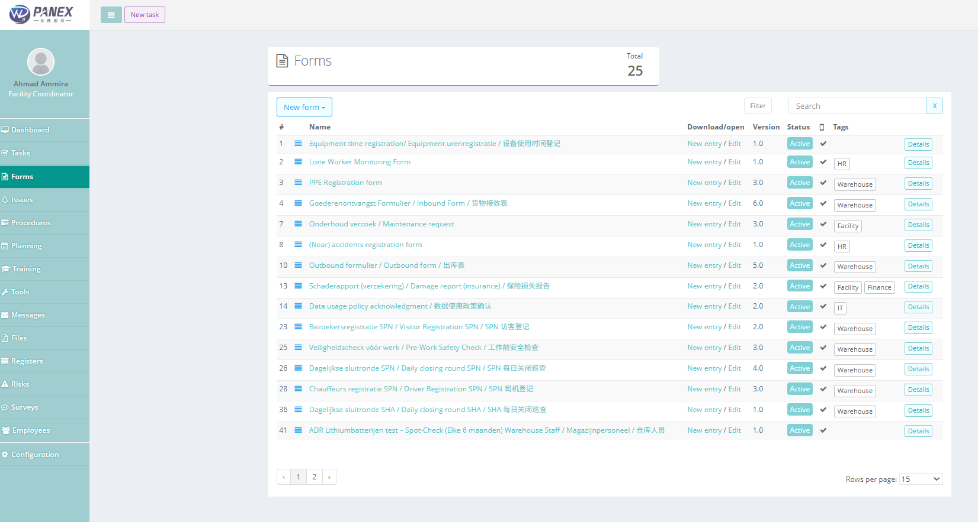
Qooling screenshot – current PANEX WD Europe environment
Example:
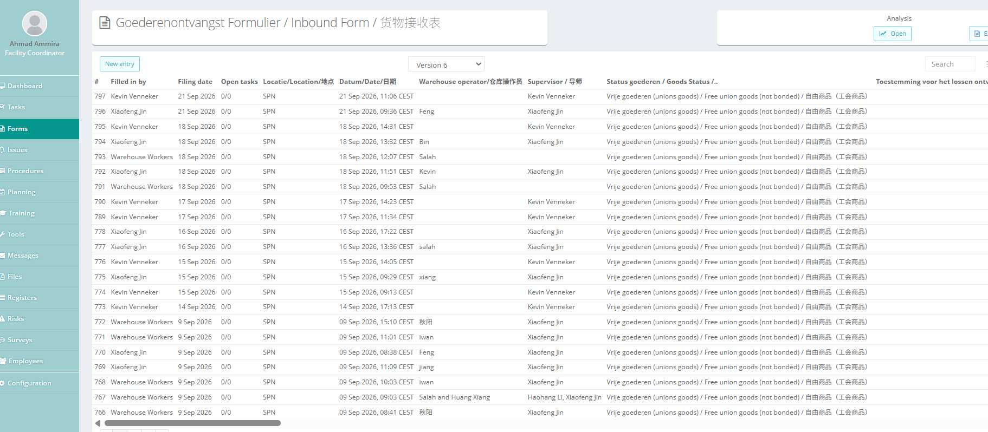

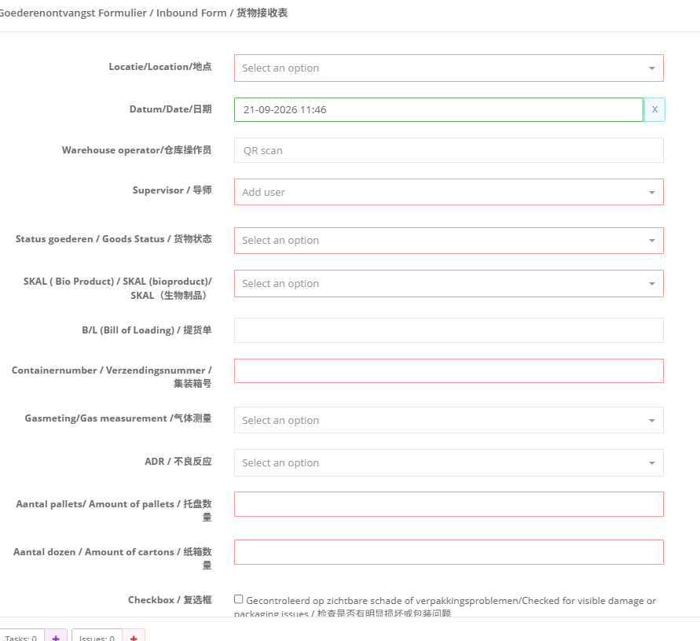

Odoo consideration Forms connected to warehouse processes should be reviewed field-by-field. In particular, the Inbound Form should be assessed against the Odoo inbound workflow so required checks and registrations can become part of the standard receiving process.

4. Issues
The Issues module is used as a central overview for reported operational issues. The supplied screen shows examples concerning EPTs, docks, wall damage, charging problems, pallet damage and forklift-related events. The overview includes a status, date and title for each issue.
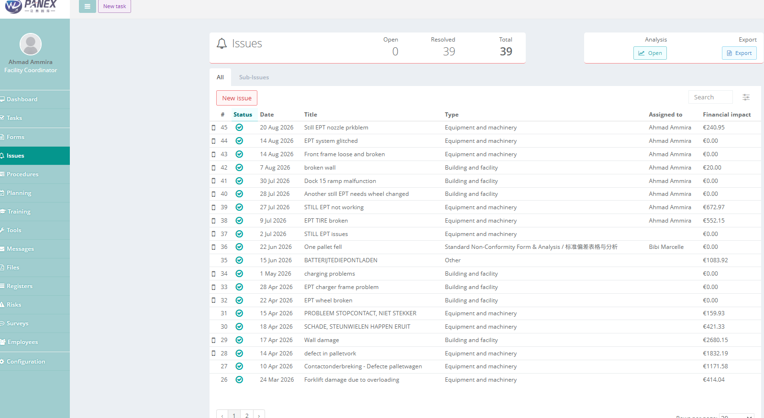
Qooling screenshot – current PANEX WD Europe environment

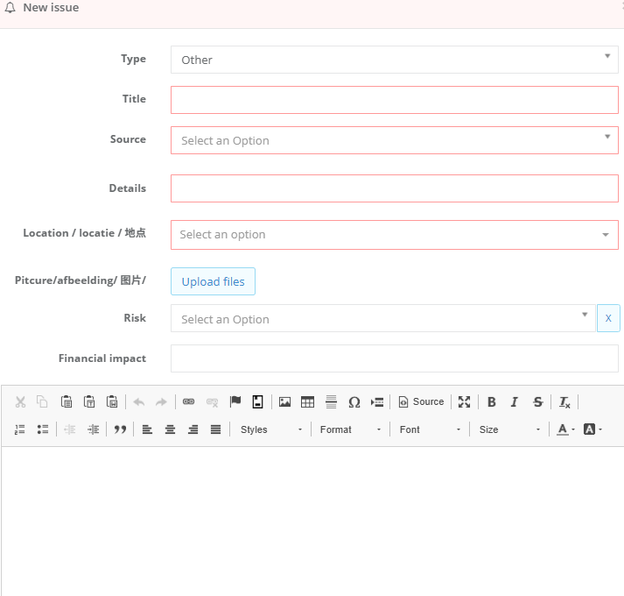

Odoo consideration Provide a structured issue/incident workflow with status, date, responsible follow-up and traceability. Where relevant, issues should be linkable to equipment, warehouse location, shipment or employee.

5. Procedures & Process Landscape
The Procedures module provides a process landscape for controlled procedures and work instructions. The supplied screens show warehouse procedures covering inbound and outbound goods processing, inbound handling, goods receipt, storage and monitoring, dispatch/loading, temperature checks, visitor registration, driver registration, pre-work safety checks and daily closing rounds.
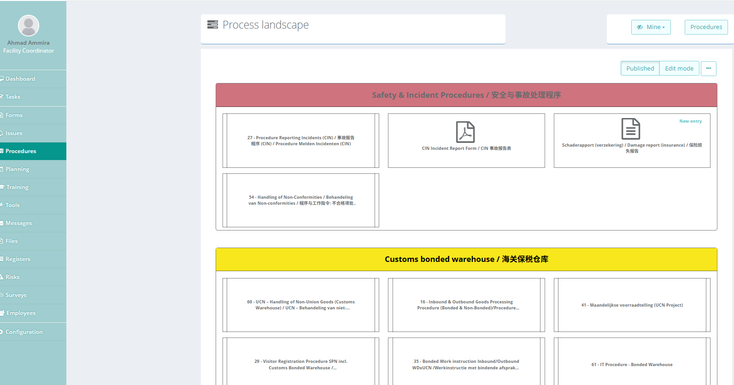
Qooling screenshot – current PANEX WD Europe environment
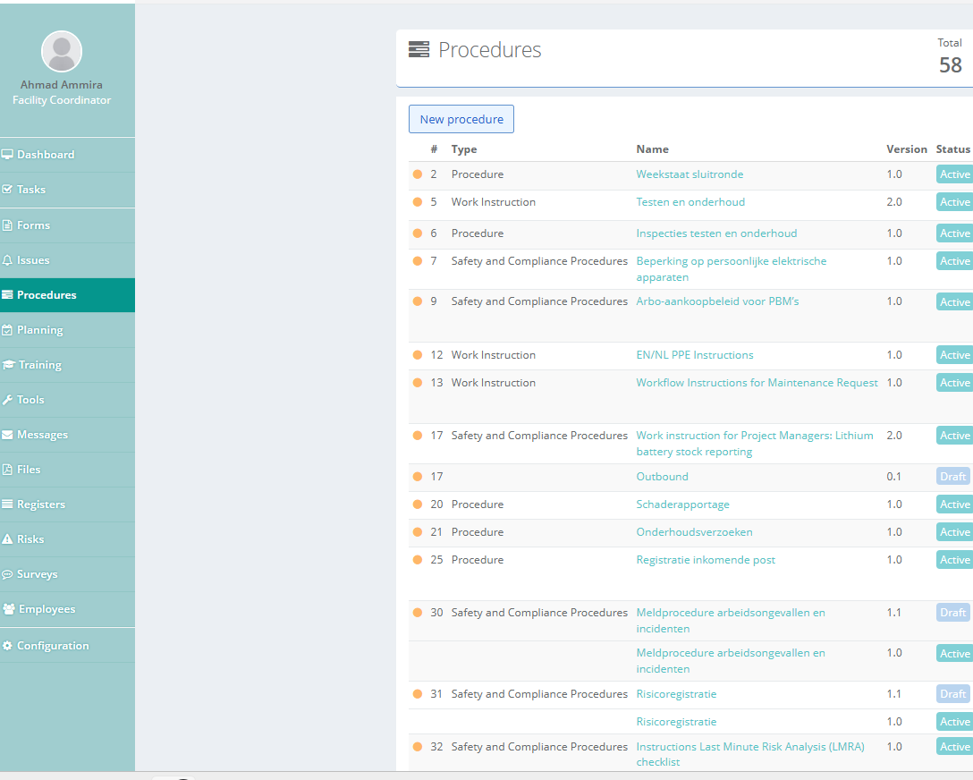

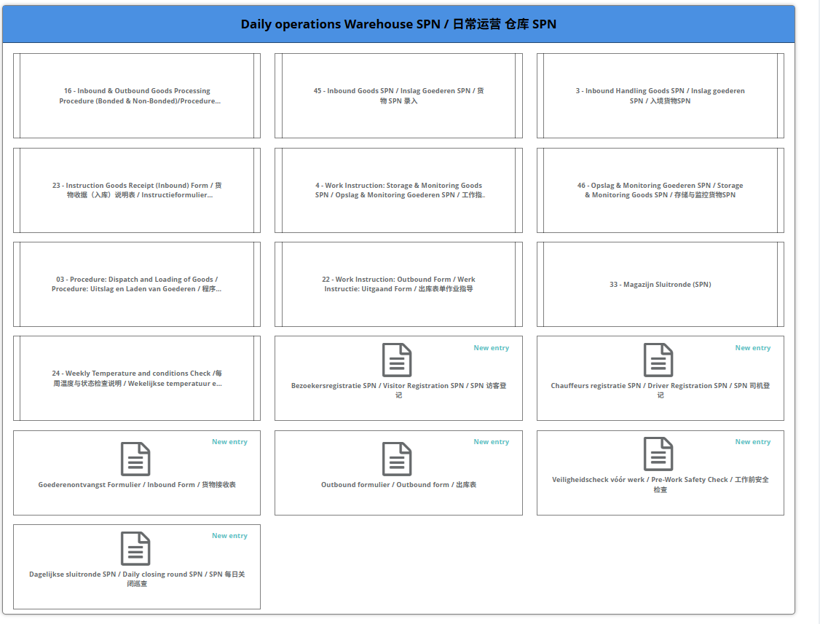

Qooling screenshot – current PANEX WD Europe environment
Odoo consideration Odoo should not only store transaction data; the relevant mandatory process steps and controls from approved procedures should be reflected in the operational workflow where appropriate.

6. Tools – Equipment, Maintenance & Inspections
The Tools module is used to register equipment and monitor recurring inspection or maintenance dates. Visible categories include pallet trucks, forklifts, racking, sprinkler/BMI and general building or site items. The overview shows the next inspection date and inspection type, making overdue or upcoming controls visible.
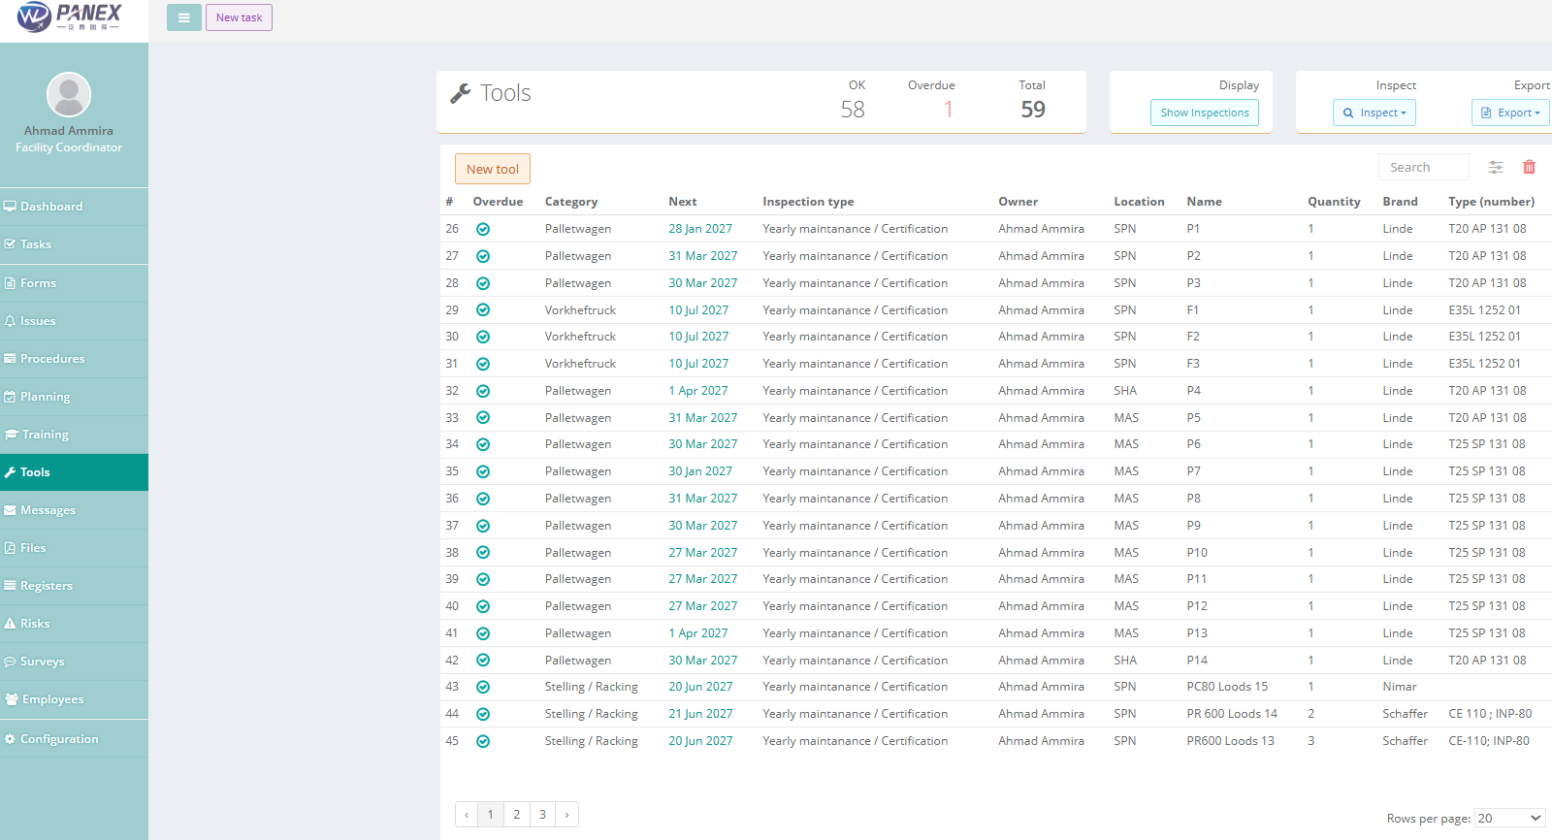
Qooling screenshot – current PANEX WD Europe environment
Odoo consideration Maintain an equipment master record with category, identification, inspection/maintenance type, next due date, status and supporting certificate or report. Notifications before due dates would reduce the risk of expired inspections.

7. Training
The Training module provides an overview of planned or recorded training. The supplied screen includes customs-related training, ADR, DG Office, fiscal representation and Lithium-ion Battery Awareness Training, and provides access to results.
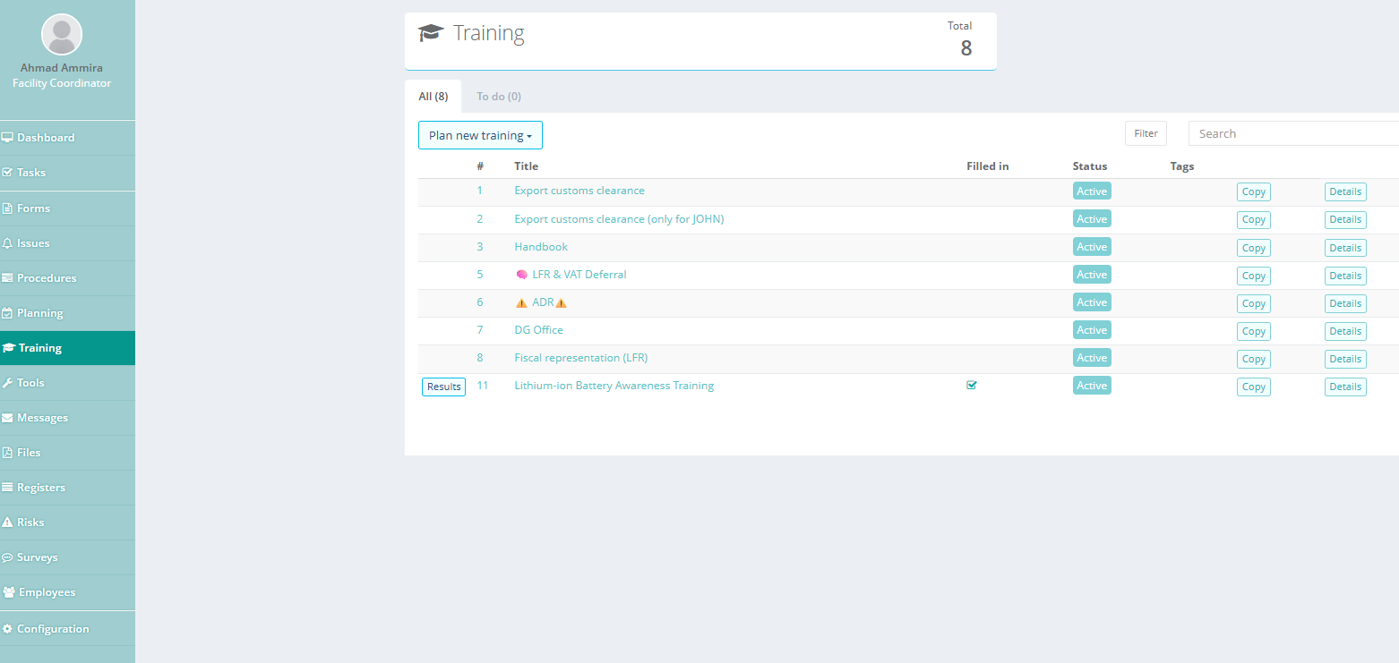
Qooling screenshot – current PANEX WD Europe environment
Odoo consideration Training records should be linkable to individual employees and, where applicable, to validity/expiry dates and required roles.

8. Files – Controlled Documentation
The Files module acts as a central location for operational and compliance documents. Examples visible in the supplied screen include emergency plans, BHV material, lithium-ion documentation, incident forms, warehouse safety material and the logistics handbook.
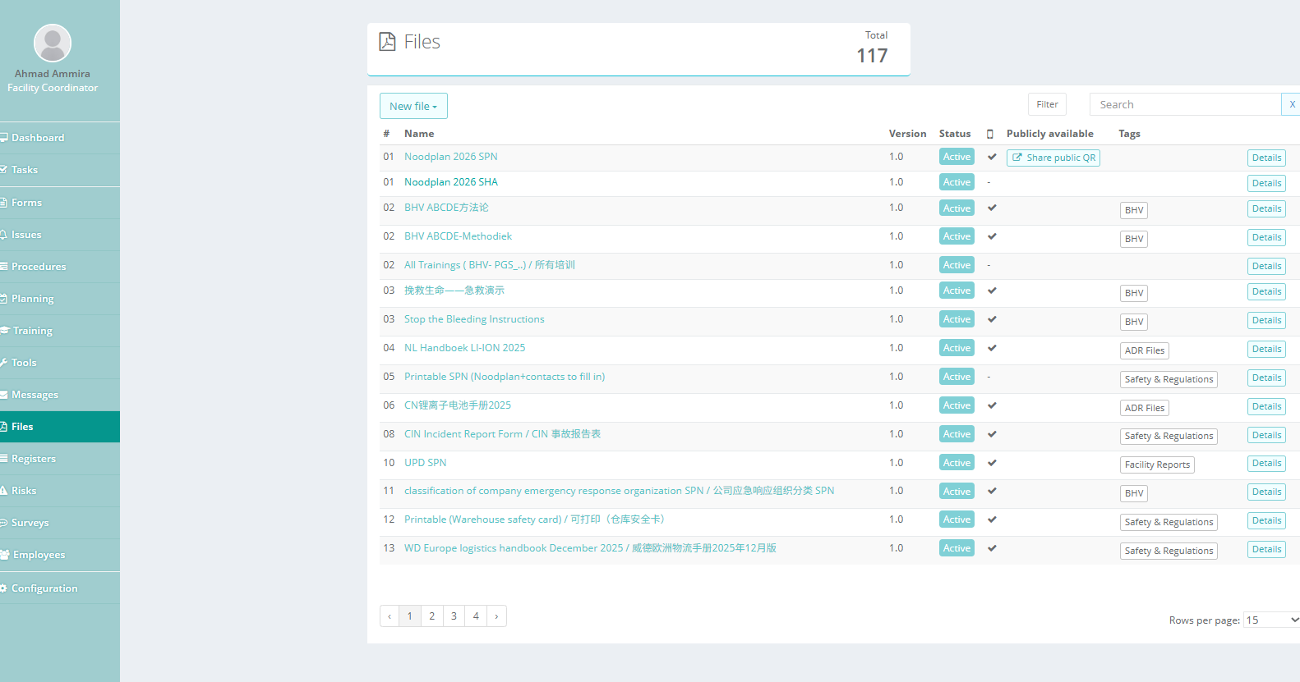
Qooling screenshot – current PANEX WD Europe environment
Odoo consideration If documents move to Odoo, define ownership, version control, access rights and a clear link between documents and the related process, equipment, training or compliance record.

9. Registers
The Registers module contains structured operational and compliance registers. Visible examples include accident/near-accident registration, UCN bonded stock count, BIO Product Docs, incident register, inspections, non-conformity reports, quarantine temperature register, Safety Data Sheet register, State of Charge (SoC) register, temperature control register and Test Report register.
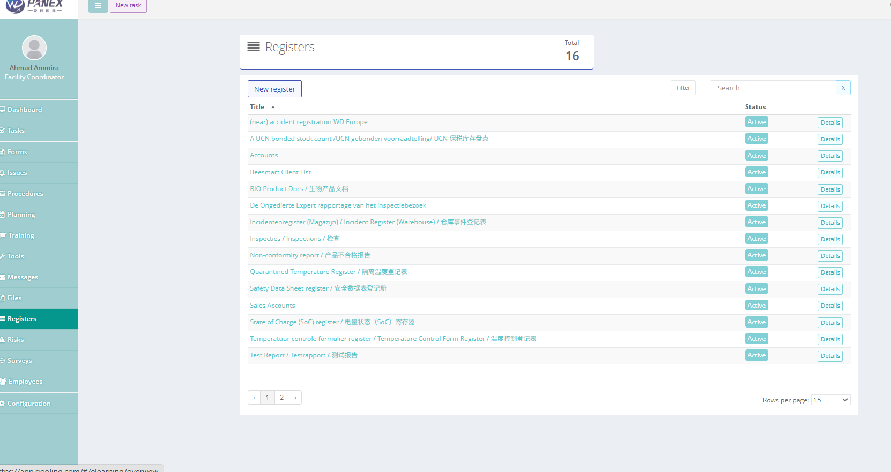

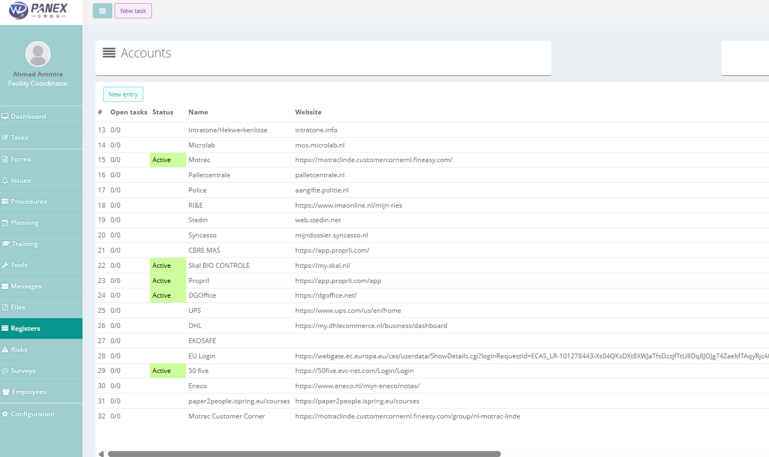
Within the Registers module, users can select Accounts to access an overview of the external accounts and systems that PANEX WD Europe has access to.
The Accounts overview contains the available accounts, including information such as the system/platform name, login URL, username, purpose of the account and relevant contact or responsible person.
Qooling navigation:
Registers → Accounts → Overview of available external accounts

Qooling screenshot – current PANEX WD Europe environment
Odoo consideration Registers that are required for traceability or compliance should remain searchable and linked to the relevant product, shipment, customer, equipment or warehouse process. Attachments such as SDS and test reports should remain retrievable from the related record.

10. Employee Management & Certificate Monitoring
The Employee Management module provides a central employee overview. Qooling also supports employee-related training/certificate follow-up in the current working process. This is important for verifying whether required qualifications are valid and for identifying certificates that are approaching expiry.
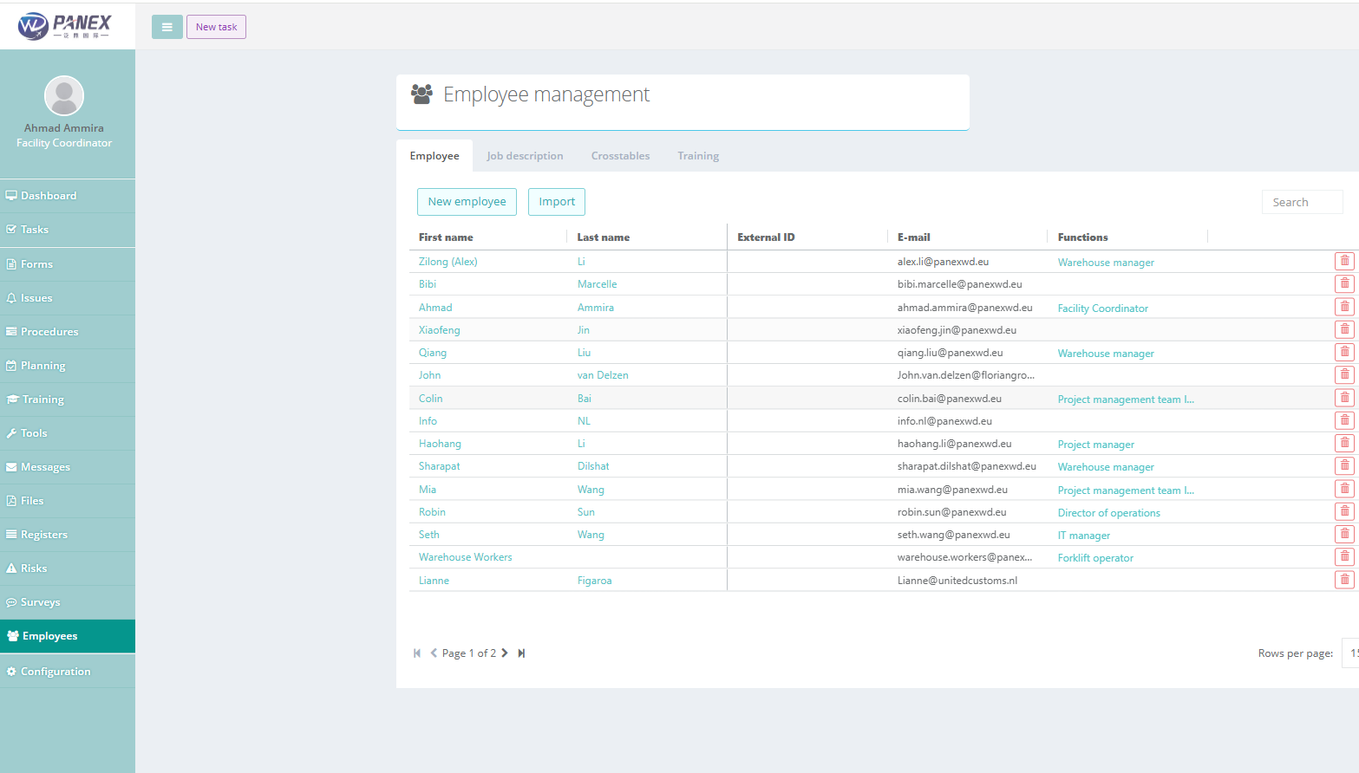

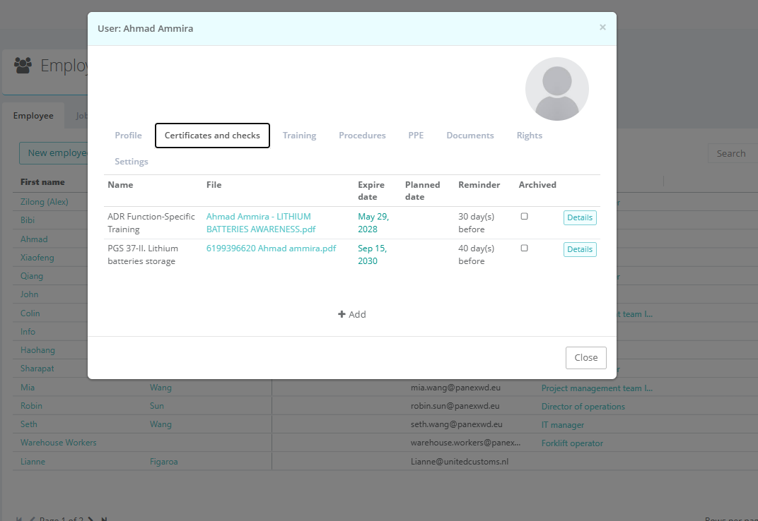

Qooling screenshot – current PANEX WD Europe environment
Odoo consideration Maintain employee training and certificates with certificate/training type, issue date, expiry date, current validity status and automatic reminders before expiration. Access should be role-based because employee records may contain personal information.

